Social Security Number Removed from Medicare ID Cards
Beginning in April 2018, the Centers for Medicare and Medicare Services (CMS) will start issuing Medicare Beneficiary Identifier (MBI) numbers in place of Health Insurance Claim Numbers (HICN) on Medicare ID cards. The new ID cards will be mailed out in phases by geographic location.

What is the goal?
The Social Security Administration hopes to decrease Medicare beneficiaries’ vulnerability to identity theft.

How will they do this?
They will replace the current SSN-based Health Insurance Claim Number (HICN) shown on Medicare ID Cards with a new Medicare Beneficiary Identifier (MBI) number that does not contain a Social Security Number.

Who does this affect?
According to Medicare, this will include all existing (currently active, deceased or archived) and new beneficiaries.

What will the new MBI number and Medicare ID Card look like?
- Same number of characters currently used (11)

- Uppercase alpha and numeric characters throughout the 11 digit MBI
- Easy to read and will limit the possibility of letters being interpreted as numbers (i.e. exclude S, L, O, I, B, Z)
- No special characters
- No inappropriate combinations of numbers or strings that may be offensive

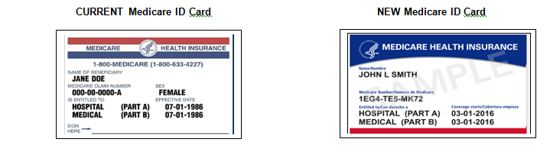

How does this affect you as an Agent?
- Updated ProCare Medicare Supplement insurance applications will begin being released in January, 2018.
- Applications will accommodate either the current HICN number or the new MBI number (same number of spaces).
- You will need to update your supply and begin using the new applications by mid-2018.
- For applicants who have not yet received their new Medicare ID card, you may continue to provide their current HICN in the Medicare Claim Number field on the application.
- Advise clients to call us and provide us their new Medicare ID number once they receive it sometime after April 2018. We will also be sending letters to clients who do not have their new number on file with us.

